

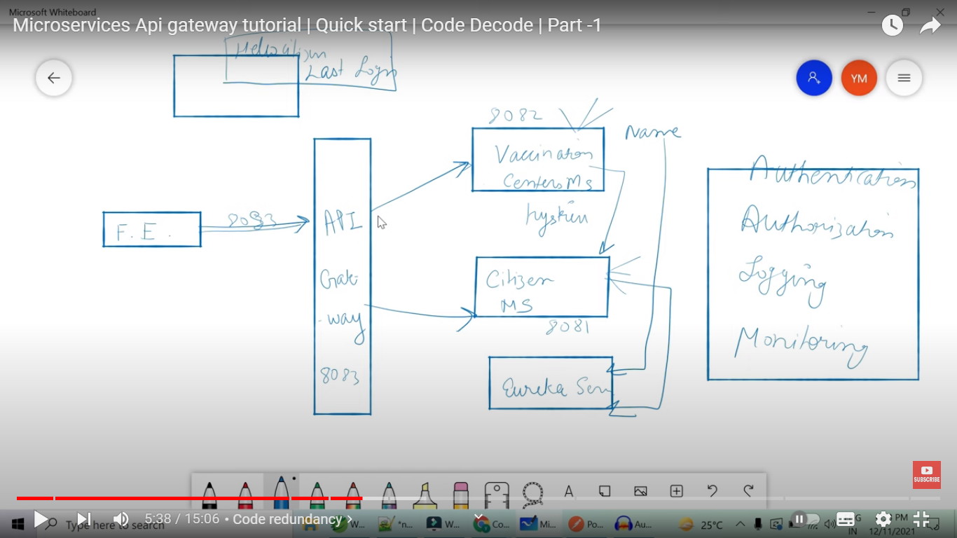

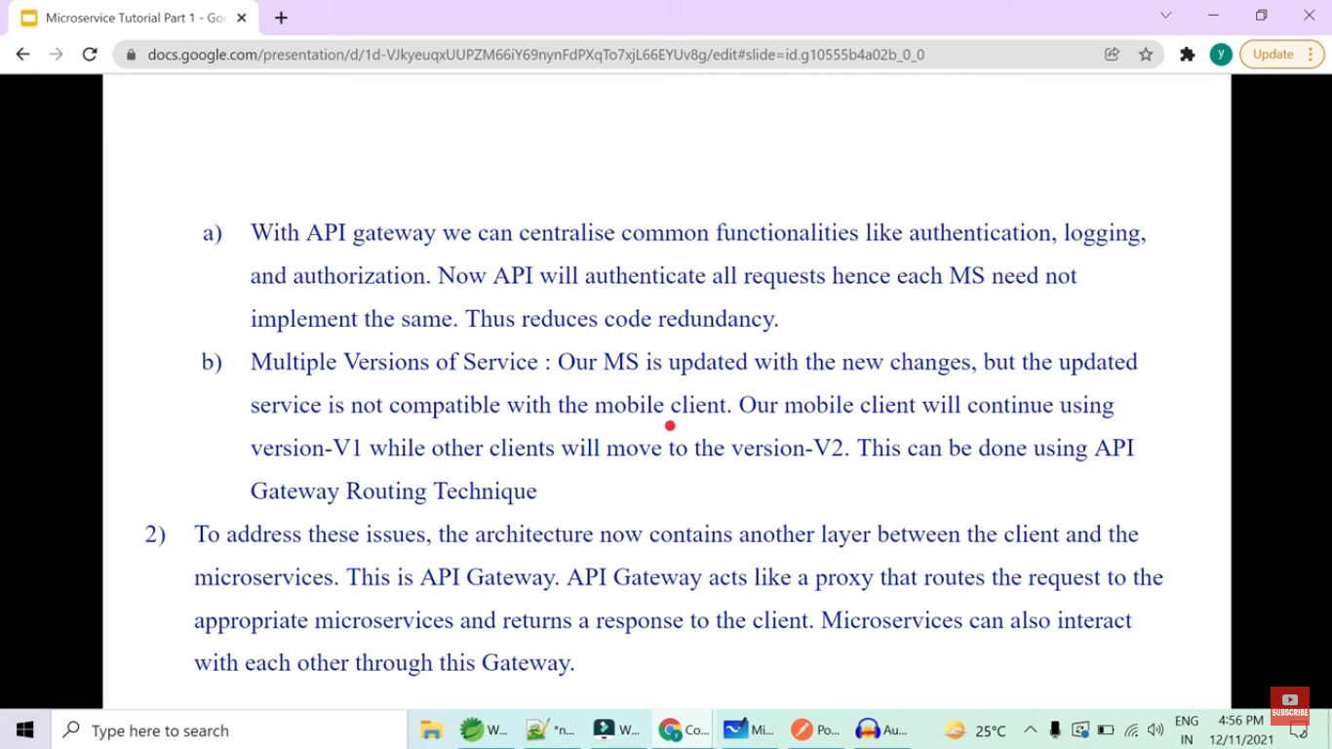

So as shown in above diagram we are creating different micro-services like vaccination Centre service, Citizen micro-service and also eureka server.

If API gateway is not there then Front end developer need to know the URL of every micro-service which is not good idea.

So We introduce another layer of abstraction by adding API Gateway which will route the traffic to different micro-service instances.

And also the features like Authentication, Authorization, Logging ,Monitoring can be implemented in API gateway itself instead of adding all those to each micro-service.

Also suppose we make change in one micro-service and now its not compatible with mobile application. So if we don’t use API Gateway then we lost the support for mobile apps.

But if we are using API gateway , we can have older version of Ms as v1 , where mobile apps can be redirected to and newer version which has no support for Mobile app , all other clients can be redirected to.

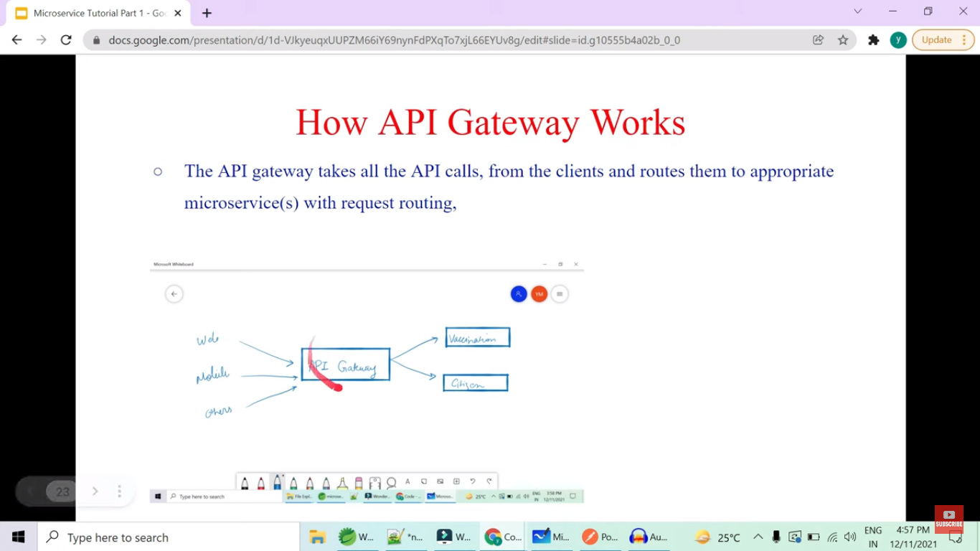

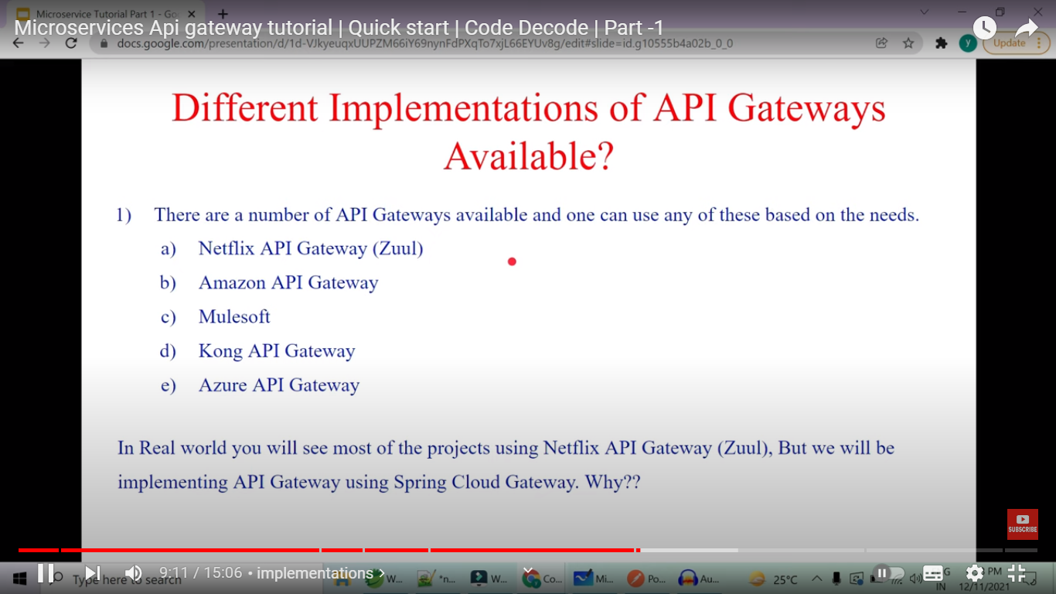

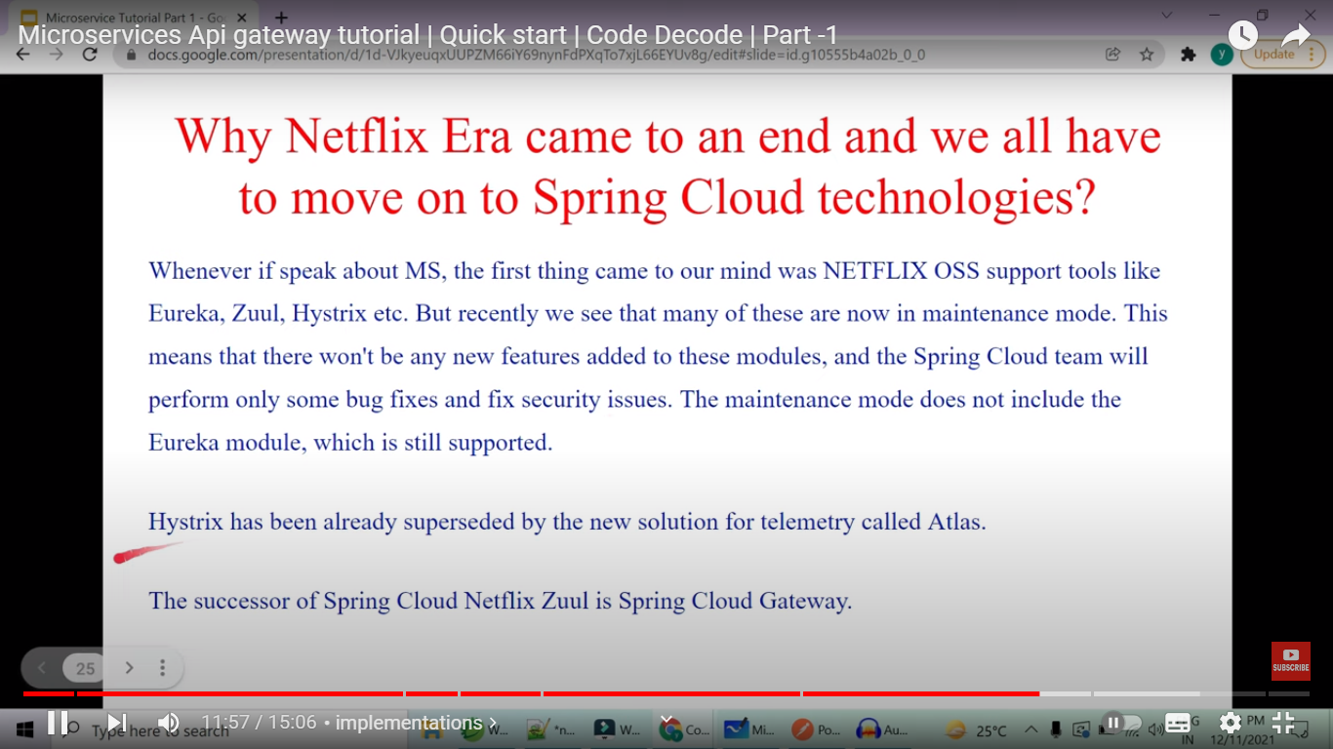

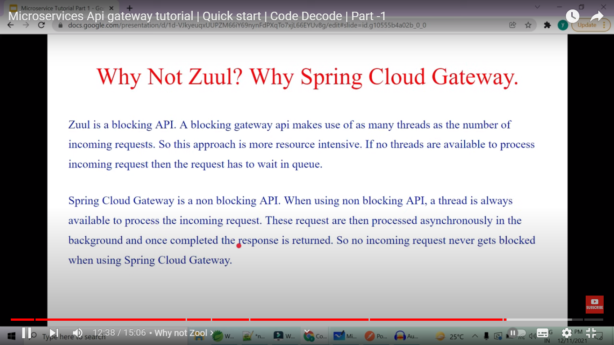

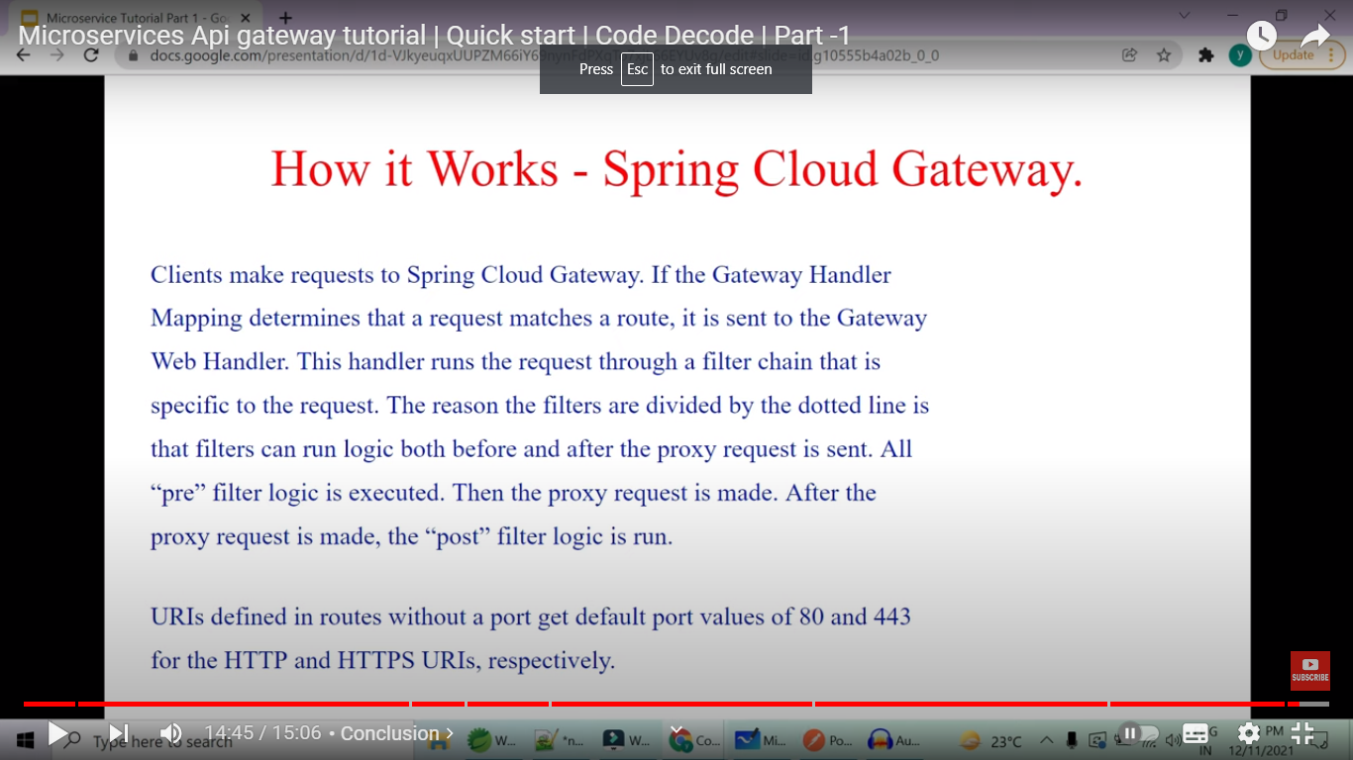

SPRING Clould Gateway is non blocking . Netflix Zuul was blocking

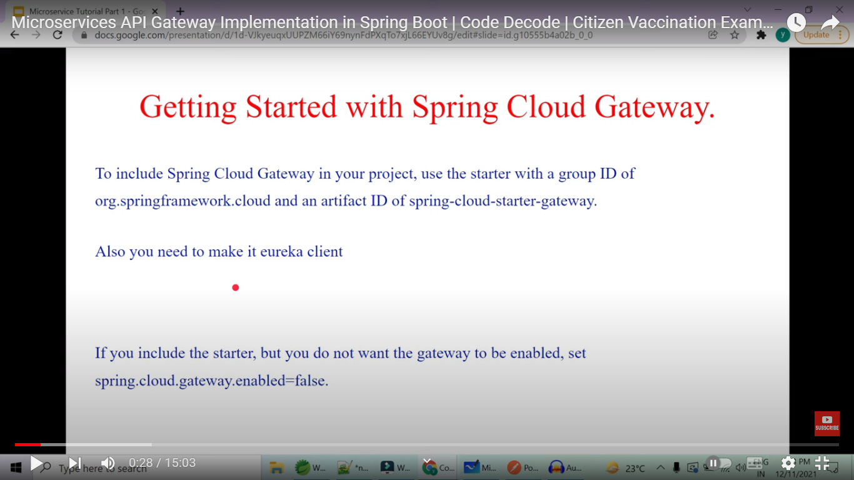

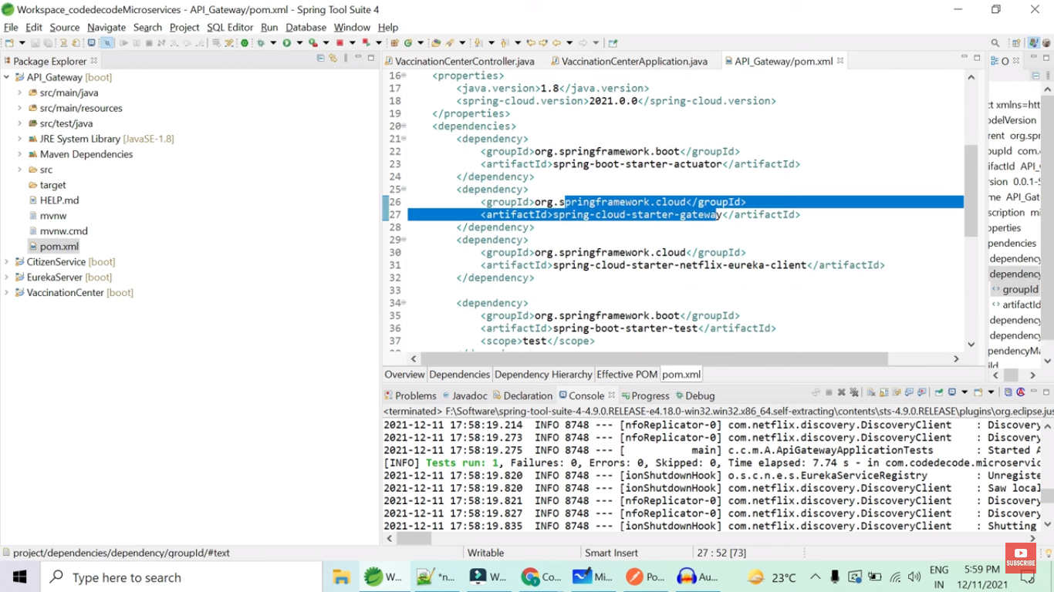

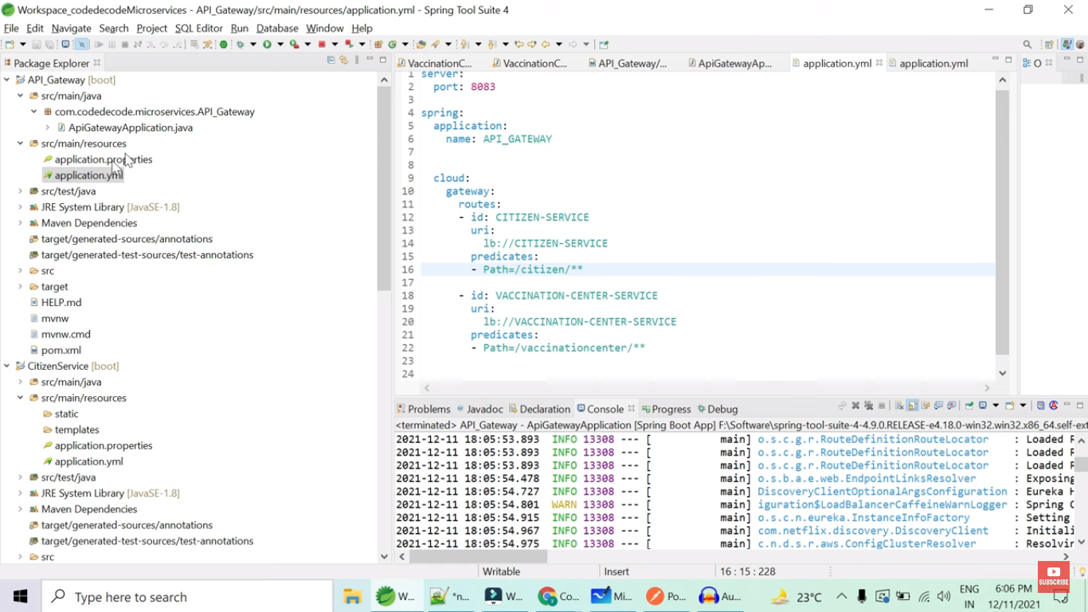

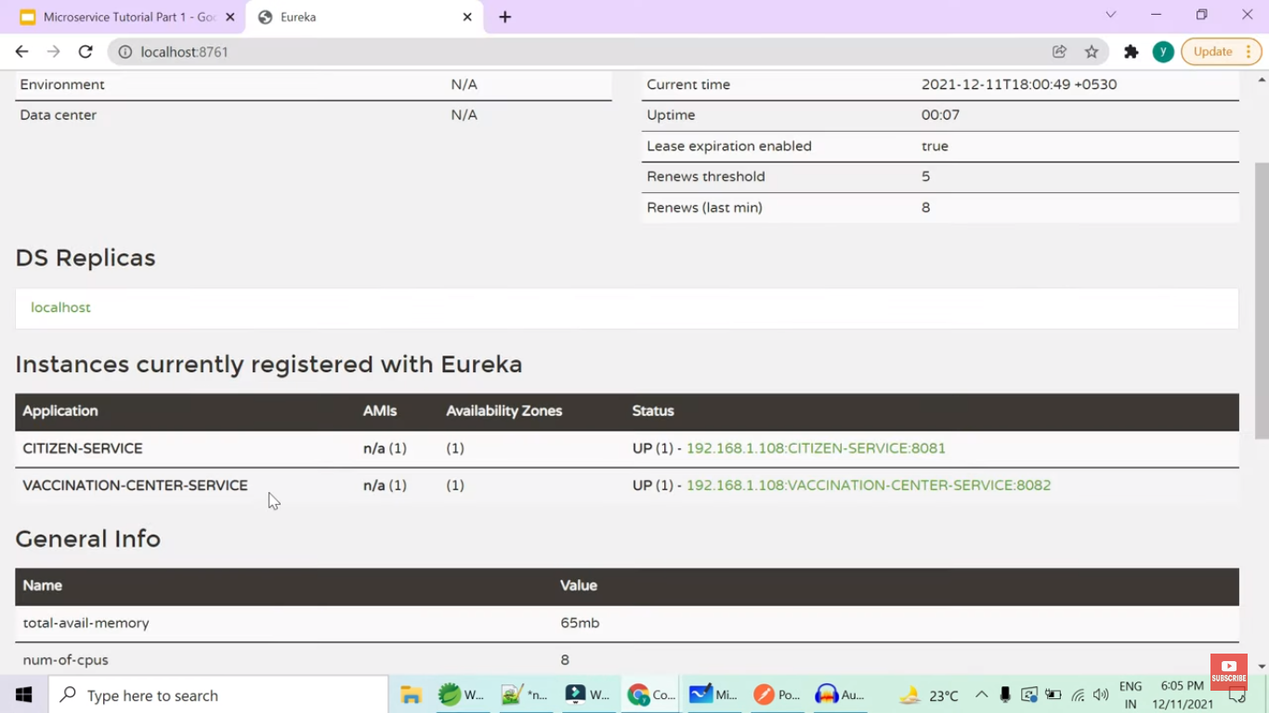

Example yaml is

spring:

cloud:

gateway:

routes:

- id: CITIZEN_SERVICE (Copy from CITIZEN_SERVICE application name)

uri: lb://CITIZEN_SERVICE (lb means load balanced)

**OR** localhost:8080/citizen-service (if we are not using eureka)

predicates:

- Path=/citizen/**

- id: VACCINATION_CENTER_SERVICE

uri: lb:// VACCINATION_CENTER _SERVICE

predicates:

- Path=/vaccinationcenter/**

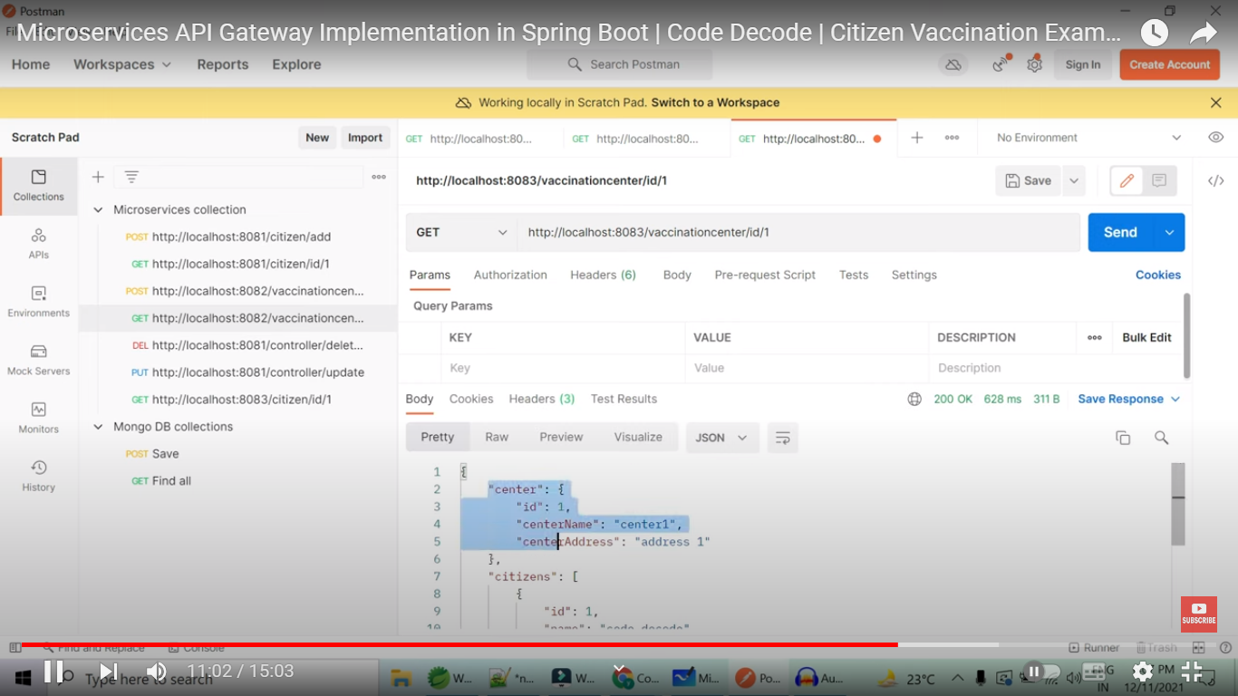

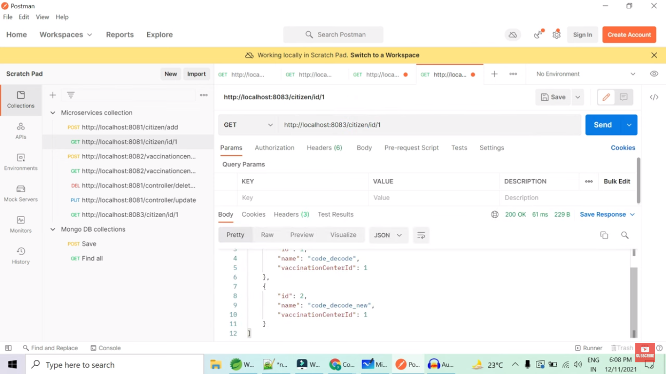

Instead of calling particular service urls , we can call API Gateway which internally routes the traffic to particular service url.

Here we are also using Eureka , so we give spring application names which are registered with eureka in cloud gateway configuration

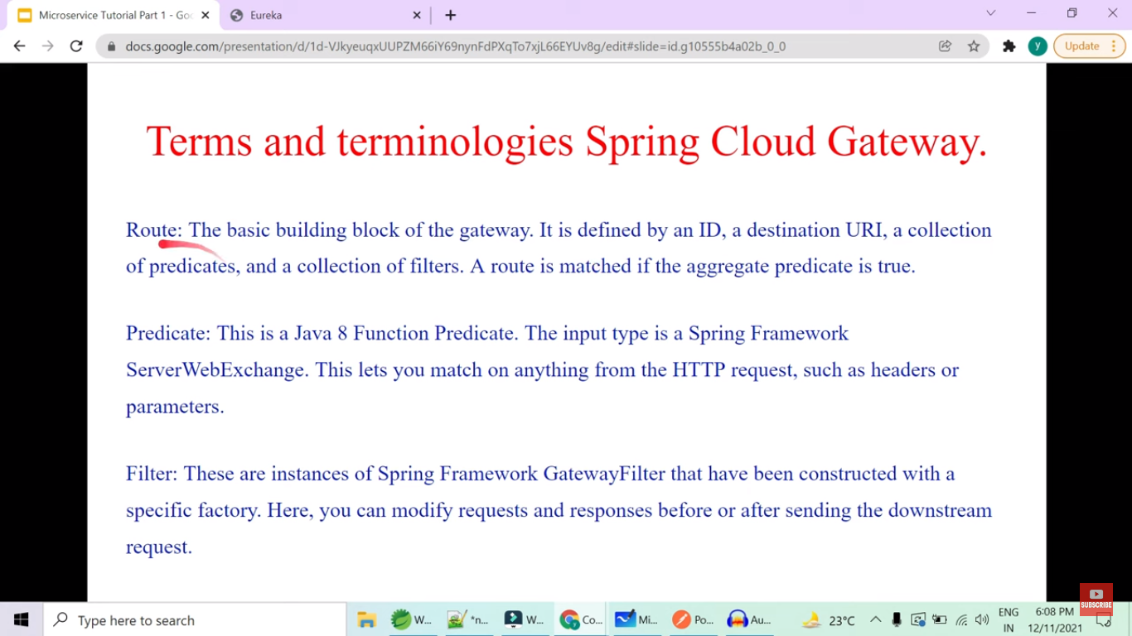

With filter we can modify request, add headers to request and response ,navigate to different URL by using pathrewrite

Also check API gateway project from in28minutes Udemy course :

F:\spring_microservices_in28Minutes_udemy\spring-microservices-v2-main\03.microservices\api-gateway

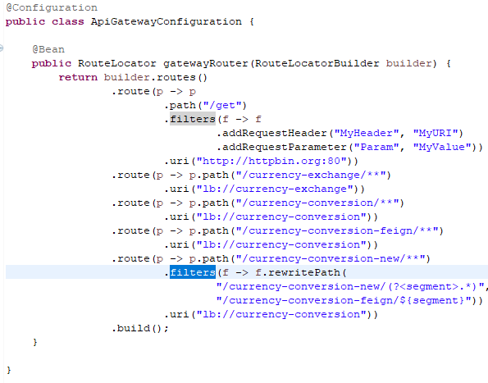

Instead of adding cloud gateway routing configuration in yml file we have created Spring Bean and used it.

